**BURGERS**

**Minute Burger**

Address: Sto Rosario Street Angeles City 2009

Contact No.: 0922 861 7182

Facebook Page: @mbbacifoods



**Barneys Burger Carmelite**

Address: 408 Business Center Sto. Rosario St. Sto.Domingo (besides Metro Bank)  
 Angeles City 2009

Contact No.: (045) 304 2155

Facebook Page: Barneys Burger Carmalite

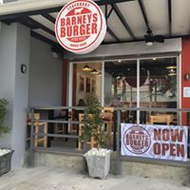

**The Messy Burger**

Address: Kucina Ni Maria, Zeppelin St., Hensonville Rd., Malabanias Angeles City

Contact No.: 0917 625 5809

Facebook Page: @TheMessyBurger



**Francis D’s Burgers**

Address: Ground floor, SM City CLARK Angeles City

Contact No.: 0920 920 7210

Facebook Page: @FrancisDsBurgers

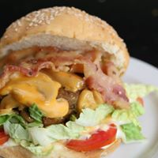

**Takeout Burgers**

Address: Nepo Mart Angeles City 2009

Contact No.: 0936 800 8862

Facebook Page: @takeoutburgers

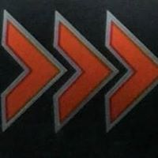

**PIZZA**

**Didi’s Pizza**

Address: MacArthur Hwy Angeles City 2009

Contact No.: (045) 892 1184

Facebook Page: @didispizza



**ZARF Pizzeria**

Address: 20-23 Richtofen St,. Hensonville, 2009 Malabañas Angeles City 2009

Contact No.: 0929 779 6000

Facebook Page: @zarfpizzeria

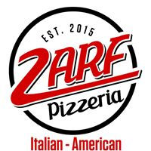

**Crusty Pizza**

Address: Rizal ext. cutcut Angeles City 2024

Contact No.: 0917 896 2400

Facebook Page: Crusty Pizza

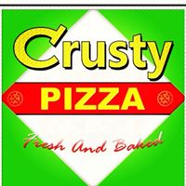

**Paizano’s Pizzeria**

Address: 4180-G Zepellin Street Angeles City 2009

Contact No.: +63 918 378 7133

Facebook Page: @PaizanosPizzeria

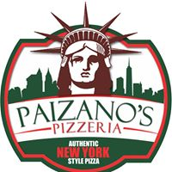

**Greenwich**

Address: G/F Nepo Mall Dona Teressa Ave. cor., St. Joseph St. Angeles 2009

Contact No.: (045) 887 1000

Facebook Page: @greenwichnepomallangeles



**SHAWARMA**

**Shawarma Dristor**

Address: Real st. corner Raymond st. Angeles City 2009

Contact No.: 0917 579 8787

Facebook Page: Shawarma Dristor Angeles City

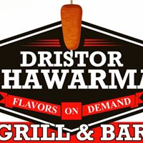

**Shawarma Shack**

Address: IBG Plaza, Mon Tang Ave., Balibago Angeles City 2009

Contact No.:

Facebook Page: @shawarmashack2018

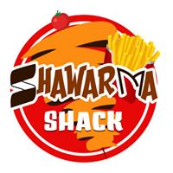

**Soldiers’ Avenue Shawarma**

Address: Angeles City 2009

Contact No.: 0926 945 0569

Facebook Page: @soldiersavenueshawarma

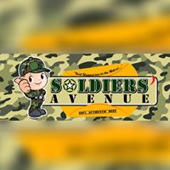

**Venshan Shawarma**

Address: walking street, fields avenue Balibago Angeles City 2009

Contact No.: 0928 209 1089

Facebook Page: @venshan.shawarma

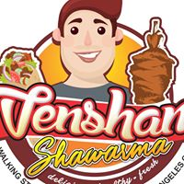

**Shawarma Mania**

Address: #254 Mc Arthur Highway, Balibago, Angeles City 2009

Contact No.: 0912 345 6789

Facebook Page: Shawarma Mania

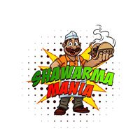

**PASTA**

**K Italian**

Address: #555 Don Juico Avenue, Malabanias Angeles 2009 Pampanga

Contact No.: 0905 616 4645

Facebook Page: K Italian  
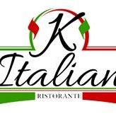

**Amore Mio**

Address: 490 Don Juico Avenue, Clarkview, Malabanias Angeles City 2009

Contact No.: (045) 304 0328

Facebook Page: Amore Mio Restaurant

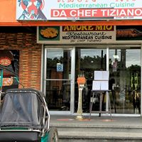

**C’ Italian Dining**

Address: 1210 Don Juico Avenue Clark Angeles City 2009

Contact No.: (045) 892 4059

Facebook Page: C’ Italian Dining – Official

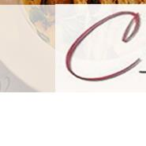

**Italian Cowboy**

Address: 6 Malabanas Rd. Angeles City 2009

Contact No.: 0905 373 3133

Facebook Page: @italiancowboy1

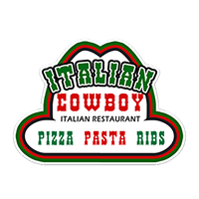

**Italianeh**

Address: 308 Vanderbilt St (2nd Block), Marisol Angeles City 2009

Contact No.: 0927 515 2165

Facebook Page: @italianeh

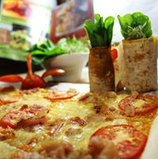

**Chicken**

**Angeles Fried Chicken**

Address: 1992 Marlim Diamond Subdivision Angeles City 2009

Contact No.: (045) 322 4448

Facebook Page: @angelesfriedchicken

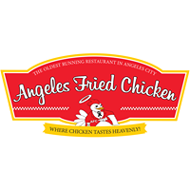

**KL Chicken Wings**

Address: 153 Edwina St. Nepo Subdivision Cut-Cut Angeles City 2009

Contact No.: 0936 416 1414

Facebook Page: @KLChickenWings

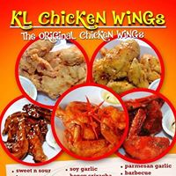

**Saku Saku Chicken**

Address: Friendship Hi-way Anunas Angeles City 2009

Contact No.: 0916 660 7105

Facebook Page: @sakusakuchick



**GREEN CUBE**

**“Chicken House”**

Address: The YARD Food Park Angeles S27 corner Mining, Pandan Road Angeles City 2009

Contact No.: 0922 780 8202

Facebook Page: @GREENCUBECHICKENHOUSE



**OH MY Chicken**

Address: 249 friendship highway brgy.anunas Angeles City 2009

Contact No.: 0906 317 1323

Facebook Page: @ohmymanuk

